TASKFLOW
SLA TaskFlow Module
Loyihalash, biznes qoidalari, UI/UX, backend arxitekturasi va AI orqali kod yozdirish uchun texnik qo‘llanma
Maqsad
Xodimlardan keladigan zayavkalarni kategoriya va prioritet bo‘yicha SLA bilan boshqarish: qabul qilish, birinchi javob, ishni boshlash, ijro, yechish, yopish, pause, qo‘shimcha vaqt, eskalatsiya, push/email xabarnoma, audit va hisobotlarni to‘liq avtomatlashtirish.

Mundarija va foydalanish tartibi
Ushbu hujjat oddiy dizayn tavsifi emas. Uni sun’iy intellektga yoki dasturchiga berib, mavjud TaskFlow loyihasida SLA modulini bosqichma-bosqich ishlab chiqish uchun texnik topshiriq sifatida ishlatish mumkin.
- 1. Hozirgi SLA sahifasining auditi
- 2. Maqsadli SLA modeli
- 3. UI/UX ekranlari va maketlar izohi
- 4. SLA taymerlari
- 5. Kategoriya, subkategoriya va prioritet bo‘yicha qoidalar
- 6. Ish kalendari va deadline hisoblash
- 7. Pause va resume qoidalari
- 8. Qo‘shimcha vaqt (extension) jarayoni
- 9. Eskalatsiya va xabarnomalar
- 10. Ticket ichidagi SLA nazorati
- 11. SLA Monitoring va rahbar paneli
- 12. Versiyalash, audit va policy matching
- 13. Backend arxitekturasi va ma’lumotlar modeli
- 14. API va eventlar
- 15. Rollar va vakolatlar
- 16. KPI, hisobotlar va eksport
- 17. Test ssenariylari va Acceptance Criteria
- 18. AI uchun tayyor master-prompt
- 19. Ishlab chiqish bosqichlari va checklist
AI bilan ishlash tartibi
AI ga 18-bo‘limdagi master-promptni va shu Word faylni bering. AI avval mavjud loyihani audit qilishi, stack va arxitekturani aniqlashi, so‘ng database migration → domain/service → scheduler/queue → API → UI → testlar ketma-ketligida ishlashi kerak. Mavjud working funksiyalarni buzmasligi shart.

1. Hozirgi SLA sahifasining auditi
Yuborilgan ekranda SLA siyosati yaratish oynasi hozircha faqat siyosat kodi, nomi, kuchga kirish/tugash sanasi va faol statusini saqlaydi. Bu administrative metadata uchun yetarli, lekin real HelpDesk/ITSM SLA boshqaruvi uchun yetarli emas.
Punkt | Hozir | Ta’siri
Kategoriya/Subkategoriya | Yo‘q | Qaysi turdagi zayavkaga qaysi SLA ishlashi aniqlanmaydi
Prioritet | Yo‘q | P1 kritik va P4 past zayavka bir xil muddatda yurishi mumkin
Assignment/Acceptance | Yo‘q | Ticket tushgandan xodim olguncha vaqt nazorat qilinmaydi
First Response | Yo‘q | Requesterga birinchi javob muddati o‘lchanmaydi
Work Start | Yo‘q | Qabul qilingan ticketning real ish boshlash vaqti nazoratsiz
Resolution/Closure | Yo‘q | Yechish va yakuniy yopish alohida yuritilmaydi
Ish kalendari | Yo‘q | Dam olish va bayram kunlarida deadline noto‘g‘ri chiqadi
Pause | Yo‘q | Requester/vendor kutish holati SLAni asossiz buzishi mumkin
Extension | Yo‘q | Qo‘shimcha vaqt so‘rash/tasdiqlash jarayoni yo‘q
Eskalatsiya | Yo‘q | Muddat yaqinlashganda rahbarlarga avtomatik signal yo‘q
Push/Email | Yo‘q | Real notification oqimi yo‘q
Versiya/Audit | Yo‘q | Policy o‘zgarsa tarixiy ticketlar hisobini izchil saqlash qiyin

Asosiy UX qaror
Hozirgi kichik modalni barcha qoidalar bilan to‘ldirish kerak emas. SLA yaratish 5 bosqichli alohida sahifa yoki 1000–1200 px kenglikdagi drawer/wizard bo‘lishi kerak. Bu murakkab policy yaratishni tushunarli qiladi.

Zayavka SLA yaratish oynasi – Yangi xolat

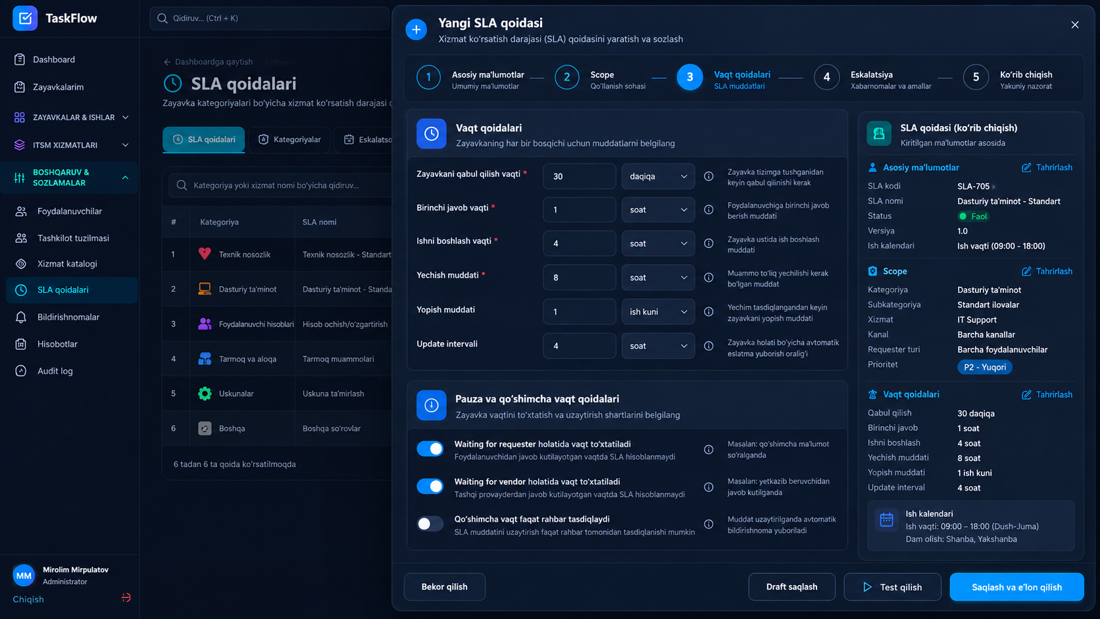

Hozirgi holat — ro‘yxat sahifasi
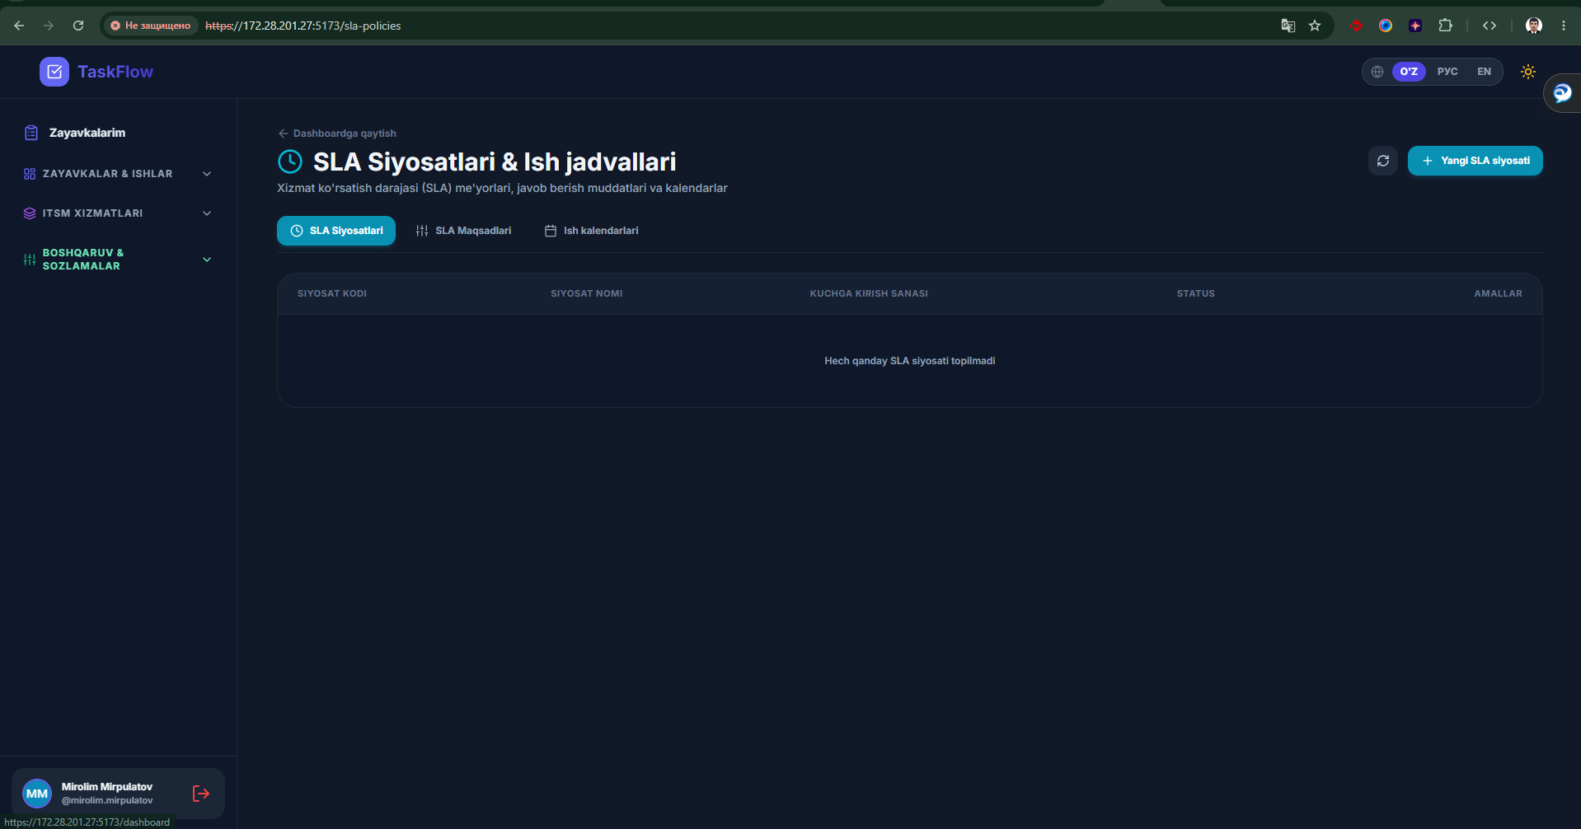
1-rasm. Hozirgi SLA Siyosatlari & Ish jadvallari sahifasi. Jadval va tabs mavjud, lekin SLA biznes qoidalari hali yetarli darajada ifodalanmagan.

Hozirgi holat — Yangi SLA modal
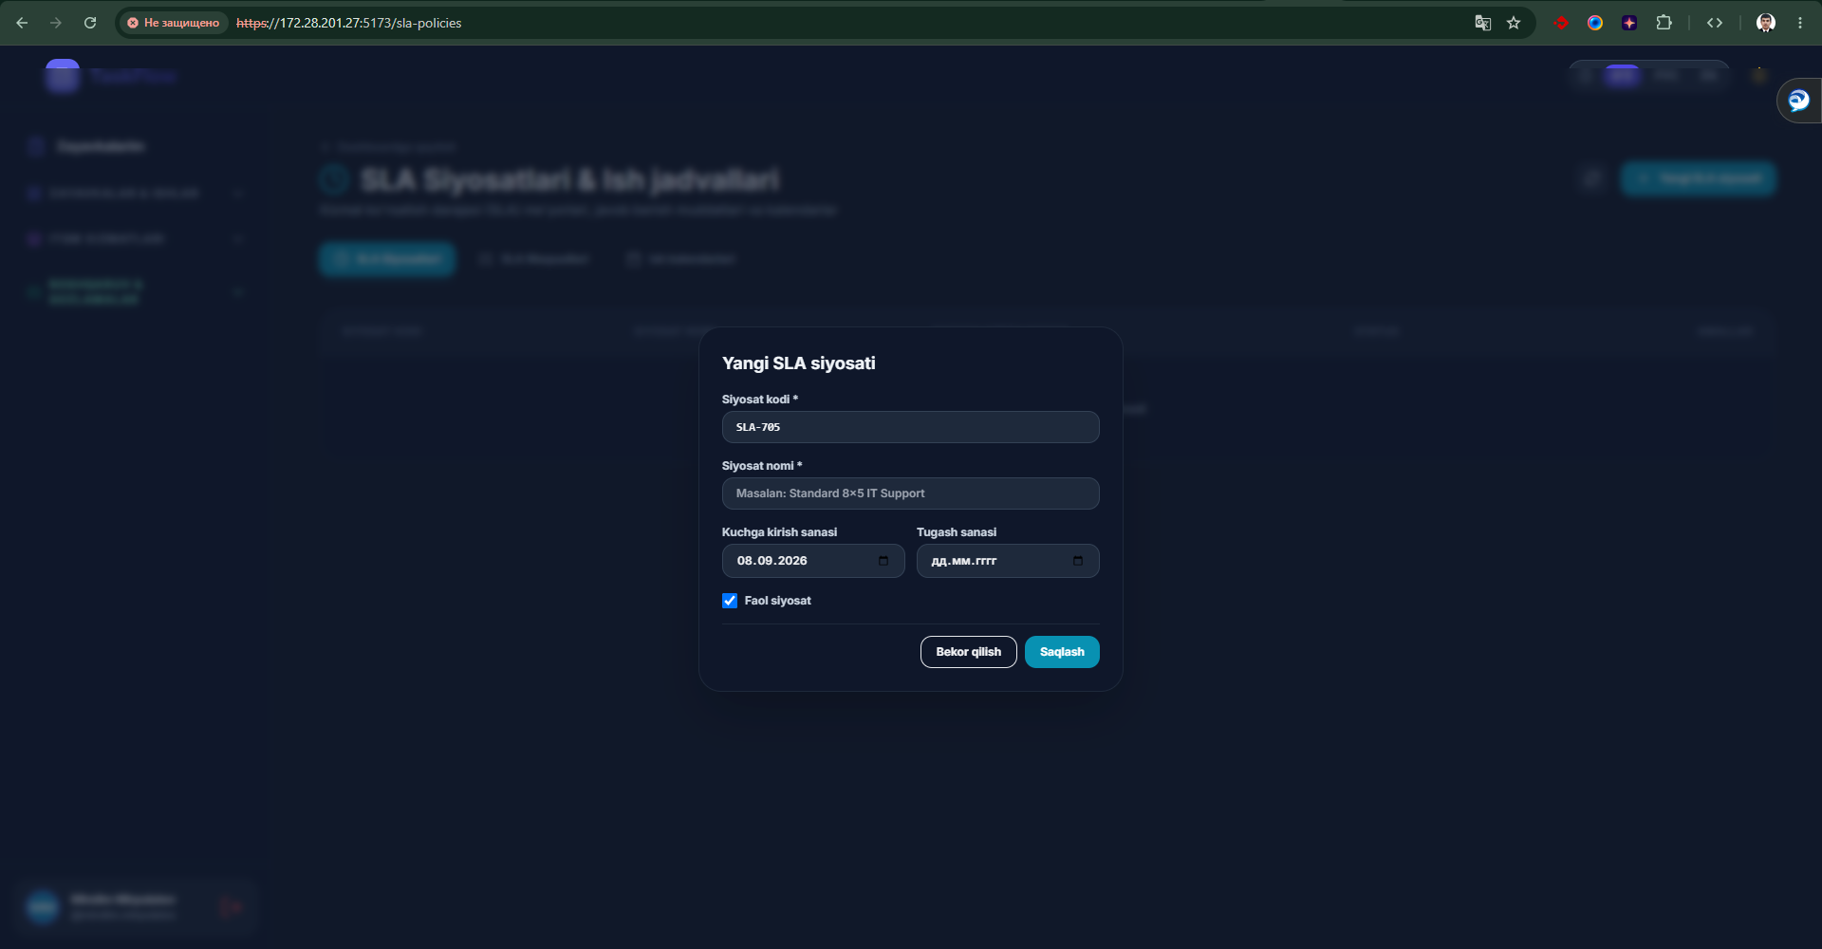
2-rasm. Hozirgi modal. Faqat metadata bor; kategoriya, vaqt targetlari, pause, extension va escalation yo‘q.

2. Maqsadli SLA modeli
Professional SLA modeli “ticket 4 soatda yopilsin” degan bitta deadline emas. U zayavkaning butun hayot siklini nazorat qiladi:
- Ticket yaratildi → to‘g‘ri guruh/xodimga biriktirildi.
- Xodim belgilangan vaqtda ticketni qabul qildi.
- Requesterga birinchi mazmunli javob berildi.
- Xodim ishni “In progress” holatiga o‘tkazib, ijroni boshladi.
- Muammo belgilangan Resolution SLA ichida yechildi.
- Resolved holatidan so‘ng ticket Closure SLA ichida yakuniy yopildi.
- Waiting holatlarida SLA faqat ruxsat berilgan sabablarda pause qilindi.
- Qo‘shimcha vaqt faqat vakolatli tasdiq bilan berildi.
- Muddat yaqinlashganda va buzilganda avtomatik eskalatsiya ishladi.
- Barcha o‘zgarish, pause, extension, breach va notification auditga yozildi.
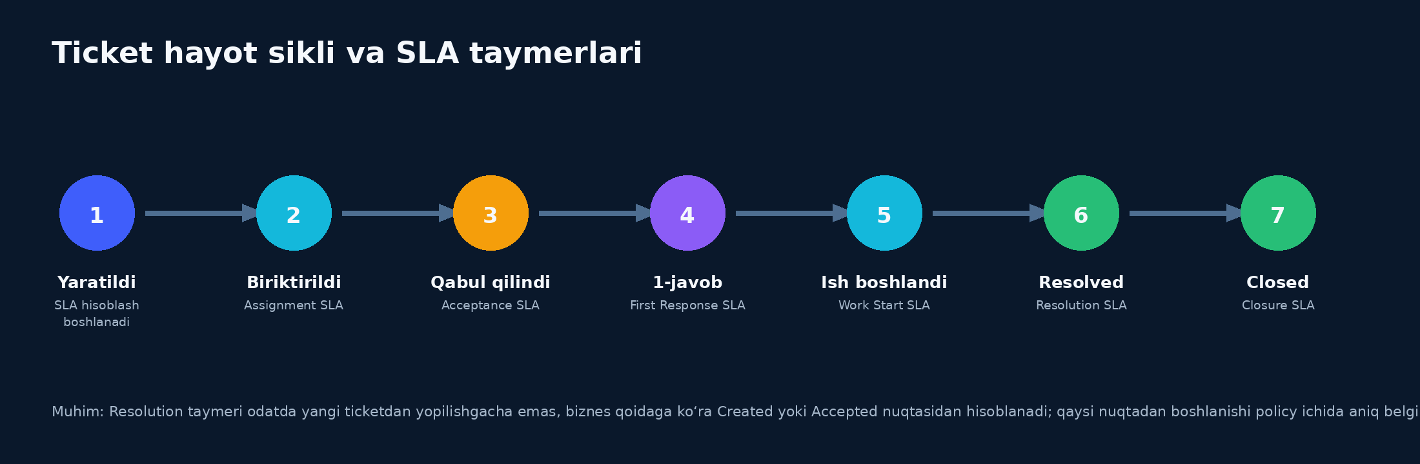
3-rasm. Ticket hayot sikli va asosiy SLA taymerlari.

2.1. SLA modulining navigatsiyasi
Tab | Vazifasi
SLA Siyosatlari | Kategoriya/subkategoriya/prioritetga qaysi policy ishlashini boshqaradi.
SLA Maqsadlari | Assignment, Acceptance, First Response, Work Start, Resolution, Closure va Update targetlari.
Eskalatsiyalar | Threshold, kimga, qaysi kanal orqali, auto-reassign va keyingi bosqich.
Ish kalendarlari | 09:00–18:00, 24/7, dam olish va bayram kunlari.
SLA Monitoring | Breach, breach risk va real-time deadline nazorati.
Hisobotlar | Compliance, average time, breach cause, employee/category/department kesimlari.

3. UI/UX ekranlari — SLA boshqaruv dashboardi
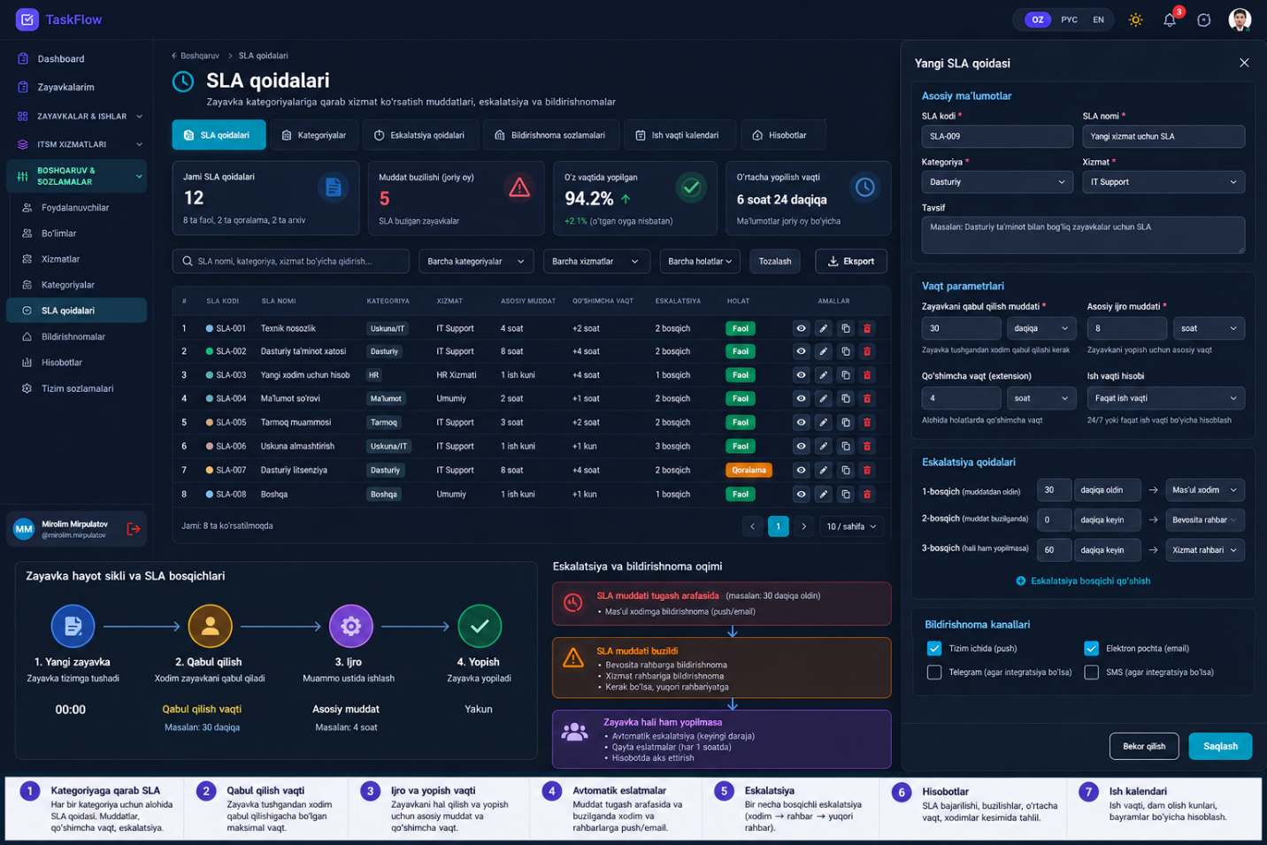

3.1. UI/UX ekranlari — 4 bosqichli SLA builder
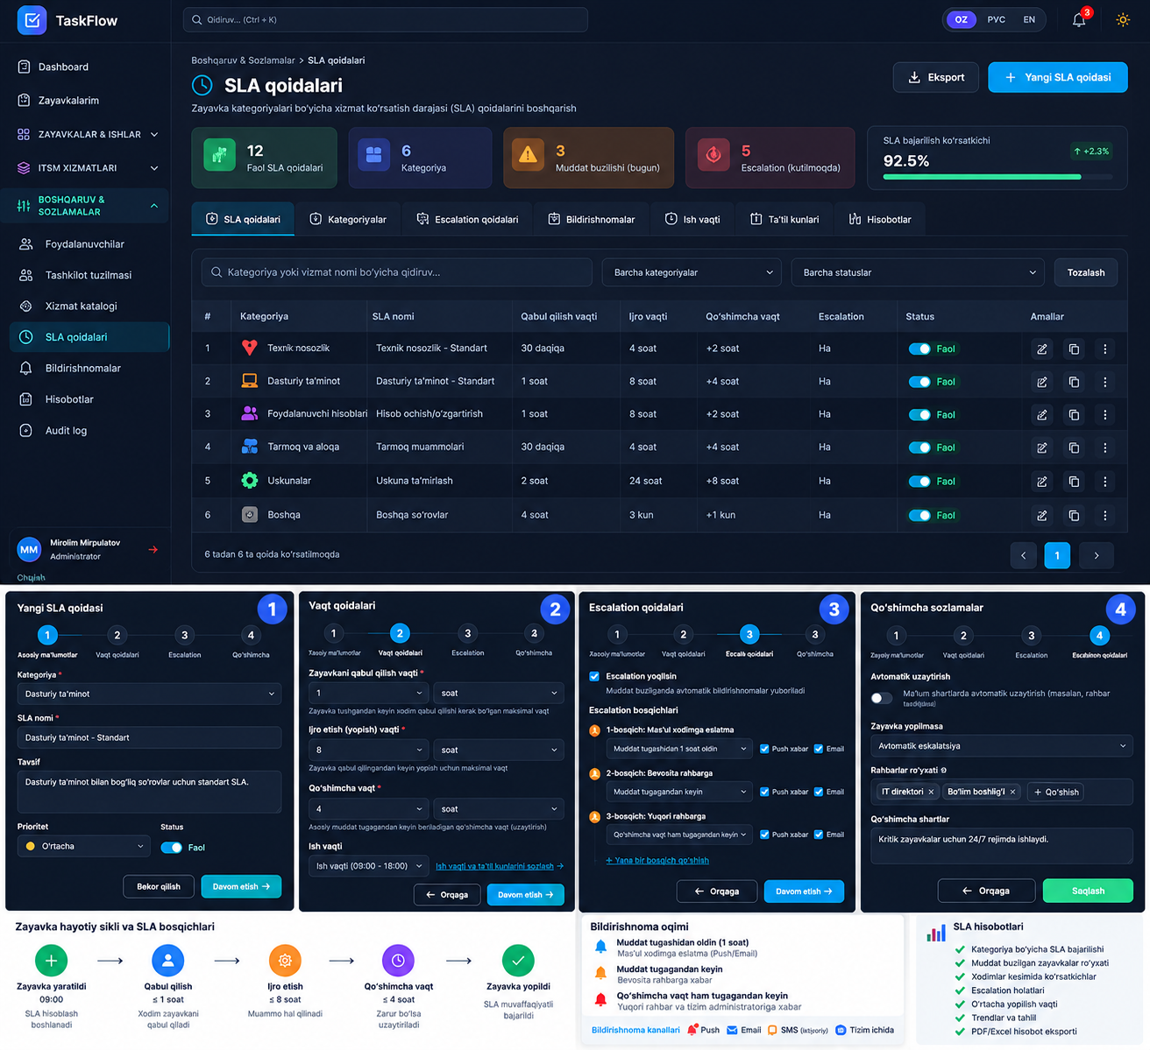
5-rasm. SLA builder konsepti: Asosiy ma’lumotlar → Vaqt qoidalari → Eskalatsiya → Qo‘shimcha sozlamalar. Pastda lifecycle, notification va hisobot bloklari ko‘rsatilgan.
Production uchun yaxshilash
Wizardni 5 bosqichga ajrating: 1) Umumiy; 2) Scope; 3) Targetlar; 4) Pause/Extension/Eskalatsiya; 5) Review/Test/Publish. Scope alohida qadam bo‘lishi shart, chunki kategoriya va prioritet policy matchingning markazi hisoblanadi.

4. Yangi SLA Policy yaratish — 5 bosqich

4.1. 1-qadam — Umumiy ma’lumot
Maydon | Talab
SLA kodi | Unique; masalan SLA-NET-P1-001.
SLA nomi | Foydalanuvchiga tushunarli nom.
Tavsif | Policy nima uchun va qaysi xizmatga tegishli.
Status | Draft / Active / Archived.
Kuchga kirish sanasi | Policy qachondan ishlaydi.
Tugash sanasi | Optional; bo‘sh bo‘lsa muddatsiz.
Versiya | Publish qilinganda immutable version yaratiladi.
Ish kalendari | Office hours yoki 24/7; majburiy.

4.2. 2-qadam — Qo‘llanish sohasi (Scope)
Policy qaysi ticketga qo‘llanishini shu qadam aniqlaydi. Scope qancha aniq bo‘lsa, policy matching shuncha ishonchli bo‘ladi.
- Kategoriya (majburiy yoki default policy uchun “Barchasi”).
- Subkategoriya (optional).
- Xizmat / service catalog item (optional).
- Prioritet: P1 Kritik, P2 Yuqori, P3 O‘rta, P4 Past.
- Tashkilot/bo‘lim/filial/hudud (agar multi-tenant yoki hududiy model bo‘lsa).
- Requester turi: xodim, rahbar, VIP, tashqi foydalanuvchi (agar kerak bo‘lsa).
- Kanal: Web, Telegram, Email, API va boshqalar.
- Policy priority: bir nechta policy mos tushganda ustuvorlik.
Matching prinsipi
Eng aniq qoida yutadi: Category+Subcategory+Priority → Category+Priority → Category → Default. Bir xil specificity bo‘lsa policy_priority qiymati ishlatiladi.

4.3. 3-qadam — SLA targetlar
Timer | Boshlanish → Yakun | Misol
Assignment SLA | Ticket yaratildi → mas’ul guruh/xodimga biriktirildi | 5–30 min
Acceptance SLA | Biriktirildi → xodim “Qabul qildim” bosdi | 5–60 min
First Response SLA | Ticket yaratildi → requesterga 1-mazmunli javob | 10 min–4 soat
Work Start SLA | Qabul qilindi → In Progress | 10 min–2 soat
Resolution SLA | Created yoki Accepted → Resolved | 2 soat–2 ish kuni
Closure SLA | Resolved → Closed | 30 min–24 soat
Update Interval | Uzoq ticketda requesterga davriy status | 1–4 soatda bir

Muhim
Har bir target uchun “calendar mode” va “start trigger” aniq saqlansin. Masalan Resolution Created’dan ham, Accepted’dan ham boshlanishi mumkin; bu policy setting bo‘ladi.

4.4. 4-qadam — Pause, Extension va Escalation
- Pause qilinadigan statuslar va majburiy pause sababi.
- Maksimal pause vaqti (optional).
- Qo‘shimcha vaqt so‘rashga ruxsat va maksimal extension.
- Extensionni kim tasdiqlashi: Team Lead / Bo‘lim rahbari / SLA Manager.
- 75/90/100/120% kabi thresholdlar.
- Har threshold uchun recipients va kanallar.
- Breach bo‘lsa auto-reassign yoki yuqori rahbarga eskalatsiya.
- Notification template va anti-spam/cooldown qoidasi.
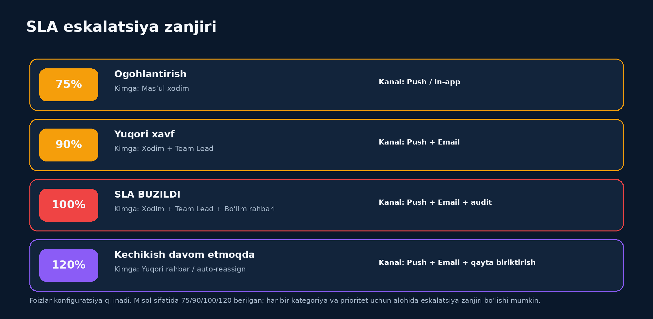
6-rasm. Eskalatsiya zanjiri misoli.

4.5. 5-qadam — Review, Test va Publish
Publishdan oldin tizim tanlangan scope va targetlarni inson o‘qiy oladigan summary ko‘rinishida chiqaradi.
SERVER / INTERNET UZILISHI / P1
Calendar: 24x7
Assignment: 5 min
Acceptance: 10 min
First Response: 10 min
Work Start: 15 min
Resolution: 2 soat
Closure: 30 min
75% -> mas'ul xodim (push)
90% -> xodim + Team Lead (push + email)
100% -> bo'lim rahbari + breach audit
120% -> auto-reassign + yuqori rahbar
Pause: Waiting for requester
Extension: max +2 soat, rahbar tasdig'i bilan

- Draft saqlash — ishlamaydi, faqat tahrirlanadi.
- Test qilish — sample ticket bilan policy matching va deadline preview.
- Publish — yangi immutable version yaratadi va Active qiladi.
- Conflict warning — shu scope uchun boshqa active policy bor bo‘lsa ogohlantirish.

5. Kategoriya va prioritet bo‘yicha SLA matrix
Quyidagi qiymatlar namunaviy. Real productionda administrator ularni UI orqali sozlaydi.
Kategoriya | Prioritet | Accept | 1-javob | Resolution | Closure | Calendar
Server ishlamayapti | P1 Kritik | 5 min | 10 min | 2 soat | 30 min | 24/7
Internet uzilishi | P1 Kritik | 5 min | 10 min | 2 soat | 30 min | 24/7
Internet sekin | P2 Yuqori | 10 min | 20 min | 4 soat | 1 soat | Office
Dastur xatosi | P2 Yuqori | 15 min | 30 min | 6 soat | 1 soat | Office
Printer | P3 O‘rta | 30 min | 1 soat | 8 soat | 2 soat | Office
Hisob ochish | P3 O‘rta | 1 soat | 2 soat | 1 ish kuni | 4 soat | Office
Dastur o‘rnatish | P4 Past | 2 soat | 4 soat | 2 ish kuni | 4 soat | Office

Default SLA
Hech qanday qoida mos tushmasa ticket SLA-siz qolmasin. DEFAULT-SLA siyosati barcha noma’lum kategoriyalar uchun fallback bo‘lib ishlaydi.

6. Ish kalendari va deadline hisoblash
SLA hisoblashda oddiy “created_at + 4 soat” formulasi noto‘g‘ri. Ish vaqti, dam olish va bayram kunlari hisobga olinishi kerak.

6.1. Calendar turlari
- Office: Dushanba–Juma 09:00–18:00.
- 24/7: kritik xizmatlar uchun uzluksiz.
- Custom shift: masalan 08:00–20:00 yoki smenali grafik.
- Holiday calendar: rasmiy dam olish va tashkilot ichki dam olish kunlari.
- Timezone: deadline barcha hisobda bir xil timezone qoidasi bilan yurishi shart.

6.2. Misol
Juma 17:30 da ticket tushdi
Resolution SLA = 4 ish soati, calendar 09:00–18:00. Juma 30 minut hisoblanadi, qolgan 3 soat 30 minut dushanba davom etadi. Deadline = Dushanba 12:30.

6.3. Deadline engine talablari
- Business minutes qo‘shish funksiyasi testlar bilan yozilsin.
- DST/timezone edge-case hisobga olinsin (agar tizim ko‘p timezone ishlatsa).
- Holiday calendar versiyalanishi yoki historical lookupni saqlashi kerak.
- Calendar o‘zgarsa eski ticket deadline’lari avtomatik qayta hisoblanmasin; policy/version va calculated deadline saqlansin.

7. Pause va Resume qoidalari
Ticket status | SLA holati | Qoida
New | Running | Assignment/First Response ishlaydi.
Assigned | Running | Acceptance ishlaydi.
Accepted | Running | Work Start/Resolution ishlaydi.
In Progress | Running | Resolution ishlaydi.
Waiting for requester | Paused | Pause sababi va timestamp majburiy.
Waiting for vendor | Configurable | Policyga qarab pause yoki running.
Resolved | Resolution stopped | Closure boshlanadi.
Closed | Stopped | Barcha timerlar yakunlanadi.
Cancelled/Duplicate | Excluded/Stopped | Compliance report qoidasi aniq belgilanadi.

Suiiste’moldan himoya
Xodim SLAni muzlatish uchun istalgan payt “Waiting” tanlay olmasligi kerak. Pause statusiga o‘tganda sabab majburiy, audit yozuvi yaratiladi; kerak bo‘lsa maksimal pause va manager approval qo‘llanadi.

8. Qo‘shimcha vaqt (Extension) jarayoni
Qo‘shimcha vaqt xodim tomonidan deadline’ni qo‘lda o‘zgartirish emas. Bu alohida tasdiqlash jarayoni.
Maydon | Talab
So‘ralayotgan vaqt | Masalan +2 soat yoki +1 ish kuni.
Sabab kodi | Vendor kutilmoqda, ehtiyot qism, murakkablik oshdi va h.k.
Izoh | Majburiy tushuntirish.
Ilova | Optional fayl/dalil.
Tasdiqlovchi | Vakolat matriksasiga ko‘ra.
Holat | Pending / Approved / Rejected / Cancelled.
SLA ta’siri | Approved bo‘lsa deadline biznes vaqtida uzaytiriladi.
Audit | Old deadline, extension, new deadline, kim tasdiqladi, vaqt.

8.1. UI oqimi
- Ticket ichida “Qo‘shimcha vaqt so‘rash” tugmasi.
- Modal: qancha vaqt + sabab + izoh + attachment.
- Tasdiqlovchiga push/email/in-app request.
- Pending vaqtida original deadline o‘zgarishi yoki “approval pending” siyosati policy setting sifatida belgilanadi. Tavsiya: original deadline yurishda davom etsin.
- Approved → deadline yangilanadi; Rejected → eski deadline saqlanadi.

9. Eskalatsiya va xabarnomalar

7-rasm. SLA warning → breach → yuqori eskalatsiya oqimi.

9.1. Notification kanallari
- In-app notification
- Browser/Mobile Push
- Email
- SMS — integratsiya mavjud bo‘lsa
- Telegram — bot/integratsiya mavjud bo‘lsa

9.2. Recipient turlari
- Mas’ul xodim
- Team Lead / guruh rahbari
- Bo‘lim boshlig‘i
- Xizmat rahbari
- SLA Manager / Administrator
- Dinamik “ticket assignee manager” zanjiri

9.3. Notification template misoli
SUBJECT: [SLA 90%] INC-2048 - Internet uzilishi
Ticket: INC-2048
Kategoriya: Tarmoq / Internet
Mas'ul: A. Aliyev
SLA turi: Resolution
Deadline: 14:30
Qolgan vaqt: 24 daqiqa
Holat: In Progress
Amal: Ticketni tekshiring yoki zarur bo'lsa eskalatsiya/extension jarayonini boshlang.

Idempotency
Scheduler har daqiqa ishlaganda bir xil 90% xabarini qayta-qayta yubormasligi shart. Har notification threshold uchun event/notification log va idempotency key saqlansin.

10. Policy matching, versiyalash va hisoblash engine’i
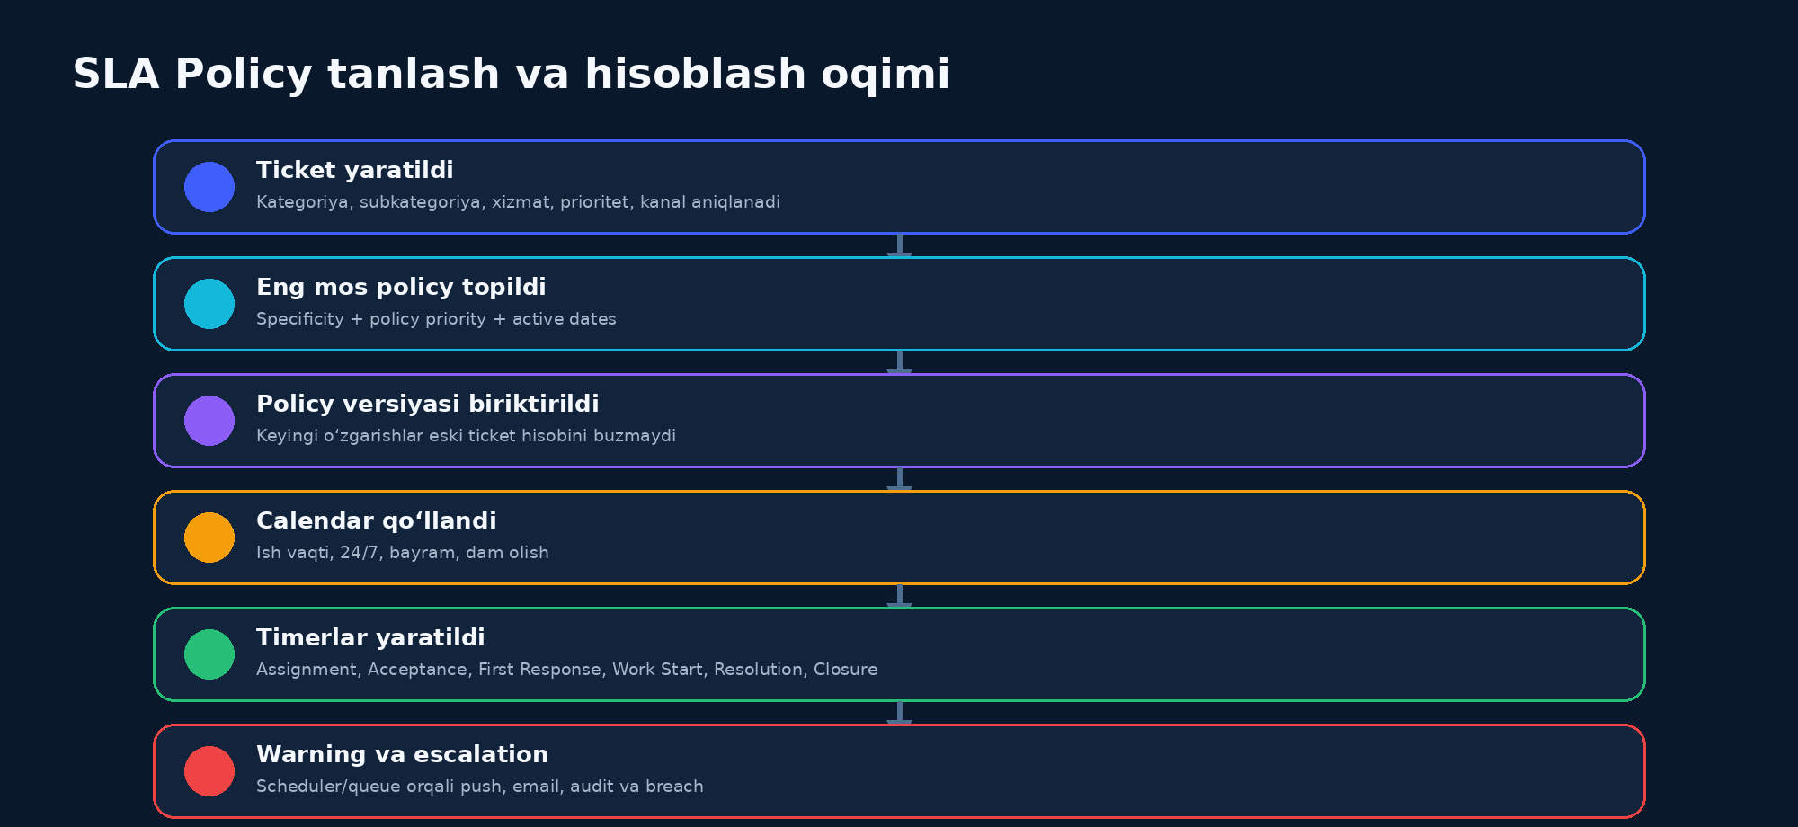
8-rasm. Ticketdan SLA instance yaratilishigacha bo‘lgan engine oqimi.

10.1. Policy versiyasi nima uchun kerak?
Masalan, SLA-001 bugun Resolution=4 soat, ertaga administrator uni 2 soatga o‘zgartirdi. Kecha yaratilgan ticketning deadline’i 2 soatga o‘zgarib ketmasligi kerak. Shuning uchun ticket “policy_id” bilan emas, aynan publish qilingan “policy_version_id” bilan bog‘lanadi.

10.2. Kategoriya yoki prioritet o‘zgarsa
Hodisa | Tavsiya etiladigan qoida
Category change | Policy re-evaluation qilinadi. Old/New policy auditga yoziladi. Recalculate strategy konfiguratsiya qilinadi.
Priority P3 → P1 | Kritik policyga o‘tish mumkin; deadline qisqarishi sabab manager/assignee ogohlantiriladi.
Reassignment | Global Resolution qayta boshlanmaydi; yangi assignee uchun Acceptance qayta ishga tushishi mumkin.
Reopen | Policy setting: old remaining time yoki new resolution target.
Manual override | Faqat vakolatli rol; sabab + old/new qiymat + audit majburiy.

11. Ticket ichidagi SLA nazorati
Ticket detail sahifasida SLA operatorga alohida tab ichida yashirinmasligi kerak. Yuqori info blokda real-time ko‘rinishi kerak.
SLA
Acceptance ✅ 04:12 / 05:00
First response ✅ 08:43 / 10:00
Resolution 🟠 01:42 qoldi [82%]
Closure — hali boshlanmagan
Policy: SLA-NET-P1 v3 | Calendar: 24x7
[Pause] [Qo'shimcha vaqt so'rash] [SLA tarixini ko'rish]

- 0–74%: normal.
- 75–89%: sariq warning.
- 90–99%: orange high risk.
- 100%+: qizil BREACHED va +00:14 kabi overdue.
- Timer frontendda countdown ko‘rsatishi mumkin, lekin source of truth backend deadline bo‘lishi kerak.

12. SLA Monitoring — rahbar uchun operativ panel
Birinchi blok
HOZIR TEKSHIRISH KERAK — 18 TA: 🔴 SLA buzilgan 4 | 🟠 90%+ 6 | 🟡 75%+ 8. Rahbar avval muammolarni ko‘rishi kerak, keyin umumiy statistika.

Ticket | Kategoriya | Mas’ul | SLA turi | Qolgan / kechikkan | Esk. | Amal
INC-2048 | Server / P1 | A. Aliyev | Resolution | -14 min | Bo‘lim rahbari | Tekshirish
INC-2051 | Network / P1 | B. Karimov | Acceptance | 2 min | Team Lead | Tekshirish
REQ-842 | Software / P2 | D. Xasanov | Resolution | 18 min | Team Lead | Tekshirish

12.1. Filterlar
Davr | Kategoriya | Subkategoriya | Prioritet | Bo‘lim | Xodim | SLA turi | Holat | Calendar | Breach status | Escalation level

13. Backend arxitekturasi va ma’lumotlar modeli

13.1. Asosiy entity/tables
Table/Entity | Vazifasi
sla_policies | Policy identity, code, name, status, priority, effective dates.
sla_policy_versions | Publish qilingan immutable snapshot.
sla_policy_scopes | Category/subcategory/service/priority/department/channel matching.
sla_targets | Timer turi, start trigger, duration, unit, calendar.
sla_calendars | Ish vaqti va timezone.
sla_calendar_days | Hafta kunlari va shiftlar.
sla_calendar_holidays | Bayram/dam olish kunlari.
sla_pause_rules | Qaysi status/reason timerlarni pause qiladi.
sla_extension_rules | Max extension, approval role, limits.
sla_escalation_rules | Threshold, delay, recipients, actions.
sla_notification_rules | Channel/template/cooldown.
ticket_sla_instances | Har ticket uchun real SLA instance va deadline’lar.
ticket_sla_events | Start/pause/resume/complete/breach/escalation timeline.
ticket_sla_extensions | Extension request/approval history.
sla_breach_events | Breach faktlari va sabab classification.
notification_deliveries | Push/email yuborish natijasi va retry.

13.2. ticket_sla_instances minimal maydonlari
id
ticket_id
policy_id
policy_version_id
target_type // assignment|acceptance|first_response|work_start|resolution|closure|update
status // pending|running|paused|completed|breached|cancelled
started_at
deadline_at
completed_at
breached_at
paused_at
total_paused_seconds
approved_extension_seconds
calendar_id
current_threshold
last_notification_at
created_at / updated_at

13.3. Domain xizmatlari
- PolicyMatcher — ticket kontekstiga eng mos active policy versionni topadi.
- BusinessTimeCalculator — calendar bo‘yicha deadline hisoblaydi.
- SlaInstanceService — target instance yaratadi/start/complete qiladi.
- SlaPauseService — pause/resume va paused durationni boshqaradi.
- SlaExtensionService — request/approve/reject va deadline extension.
- SlaEscalationService — threshold va recipients/actionsni bajaradi.
- NotificationService — push/email va retry/idempotency.
- SlaAuditService — barcha muhim o‘zgarishlarni event/auditga yozadi.

13.4. Scheduler / Queue
Har daqiqa barcha ticketlarni full-scan qilish katta tizimda samarasiz. Deadline va next_escalation_at bo‘yicha indexed query yoki delayed jobs/priority queue ishlatish tavsiya qilinadi.
Every minute / worker:
1) next_escalation_at <= now AND status in (running, paused-rule-dependent)
2) lock row / idempotency check
3) calculate current SLA percentage
4) fire required warning/breach/escalation event once
5) enqueue notification jobs
6) set next_escalation_at to following threshold
7) persist audit + delivery status

14. API va eventlar

14.1. Admin API
GET /api/sla/policies
POST /api/sla/policies
GET /api/sla/policies/{id}
PUT /api/sla/policies/{id}
POST /api/sla/policies/{id}/publish
POST /api/sla/policies/{id}/clone
POST /api/sla/policies/{id}/archive
POST /api/sla/policies/test-match
GET /api/sla/calendars
POST /api/sla/calendars
PUT /api/sla/calendars/{id}
GET /api/sla/escalations
POST /api/sla/escalations

14.2. Ticket SLA API
GET /api/tickets/{ticket}/sla
GET /api/tickets/{ticket}/sla/history
POST /api/tickets/{ticket}/sla/pause
POST /api/tickets/{ticket}/sla/resume
POST /api/tickets/{ticket}/sla/extensions
POST /api/tickets/{ticket}/sla/extensions/{id}/approve
POST /api/tickets/{ticket}/sla/extensions/{id}/reject

14.3. Domain eventlar
TicketCreated
TicketAssigned
TicketAccepted
TicketFirstResponseSent
TicketWorkStarted
TicketStatusChanged
TicketPaused
TicketResumed
TicketResolved
TicketClosed
TicketReopened
TicketCategoryChanged
TicketPriorityChanged
TicketReassigned
SlaExtensionRequested
SlaExtensionApproved
SlaTargetWarning
SlaTargetBreached
SlaEscalated

15. Rollar va vakolatlar
Rol | Vakolat
Agent/Xodim | Ticketni qabul qilish, ishni boshlash, ruxsatli pause, extension so‘rash, SLA holatini ko‘rish.
Team Lead | Team ticketlarini ko‘rish, extension tasdiqlash (policyga ko‘ra), escalation qabul qilish.
Department Manager | Yuqori escalation, bo‘lim KPI va breach monitoring.
SLA Manager | Policy/calendars/escalations yaratish, publish, version, report.
Administrator | Texnik sozlamalar va integratsiyalar; auditni buzmasdan boshqarish.
Auditor/Read-only | SLA tarixlari, audit, report; write yo‘q.

Security
Agent deadline, breach flag yoki approved extensionni API orqali qo‘lda o‘zgartira olmasligi kerak. Server-side authorization va immutable audit shart.

16. KPI, hisobotlar va eksport
- Acceptance SLA %
- First Response SLA %
- Resolution SLA %
- Closure SLA %
- SLA breached count / breach rate
- Average first response time
- Average resolution time
- Median/P90/P95 resolution time
- Extension so‘rovlar soni va approval rate
- Pause duration va pause sabablari
- Kategoriya bo‘yicha compliance
- Xodim bo‘yicha compliance
- Bo‘lim bo‘yicha compliance
- Escalation count va level
- Breach sabab classification
- Trend: kun/hafta/oy
- PDF/XLSX/CSV eksport + export audit

16.1. KPI hisobida ehtiyot bo‘ladigan holatlar
- Cancelled va Duplicate ticketlar compliance denominatoriga kiradimi — konfiguratsiya va reportda aniq ko‘rsatiladi.
- Reopened ticketlar alohida metric bo‘lishi mumkin.
- Policy versiyasi bo‘yicha report qilish imkoniyati bo‘lsin.
- Calendar va timezone reportdagi deadline bilan mos chiqishi kerak.

17. Test ssenariylari va Acceptance Criteria

17.1. Majburiy funksional testlar
Test | Kutilgan natija
Policy matching | Category+Subcategory+P1 policy Category-only policydan ustun tanlanadi.
Fallback | Hech policy mos kelmasa DEFAULT-SLA ishlaydi.
Acceptance | Assigned bo‘lganda Acceptance boshlanadi; Accepted bo‘lganda completed.
Calendar | Juma 17:30 + 4 business hours = Dushanba 12:30 (09–18 calendar, holiday yo‘q).
Holiday | Deadline bayram kunini tashlab o‘tadi.
Pause | Waiting for requester’da Resolution pause; resume’da qolgan vaqt saqlanadi.
Extension approve | Approved +2h deadline’ga calendar bo‘yicha qo‘shiladi.
Extension reject | Deadline o‘zgarmaydi.
Escalation 90% | Xodim+Team Leadga bir marta notification.
Breach | 100% da breached_at va breach event yaratiladi.
Idempotency | Scheduler qayta ishlasa duplicate email/push ketmaydi.
Reassign | Resolution reset qilinmaydi; acceptance yangi assignee uchun policyga ko‘ra qayta boshlaydi.
Policy version | Policy v2 publish eski ticket v1 deadline’ini o‘zgartirmaydi.
Auth | Agent admin SLA policy endpointini o‘zgartira olmaydi.

17.2. UI Acceptance Criteria
- SLA policy yaratish 5 aniq bosqichda, majburiy maydon validation bilan.
- Scope konfliktda warning chiqadi.
- Targetlar bo‘sh yoki manfiy qiymat qabul qilmaydi.
- Ticket detailda deadline va qolgan vaqt server qiymatidan chiqadi.
- Breach/risk rang bilan birga matn va ikonka orqali ham ajratiladi (accessibility).
- Mobile/tablet layoutda asosiy SLA holati yo‘qolmaydi.
- Notification recipients preview qilinadi.
- Publishdan oldin human-readable summary va Test Match mavjud.

18. Sun’iy intellektga beriladigan MASTER-PROMPT
Qanday foydalaniladi
Quyidagi promptni to‘liq nusxalab AI coding agentga bering va shu Word faylni reference sifatida biriktiring. Agar agent loyiha repositorysiga kira olsa, birinchi qadamda audit qilsin.

SENING ROLING:
Sen Senior Software Architect, Senior Backend Engineer, Senior Frontend Engineer va Senior UI/UX Product Designer sifatida ishlaysan.
LOYIHA:
Mavjud TaskFlow HelpDesk/ITSM loyihasida professional SLA Management modulini production darajada ishlab chiqish kerak. Mavjud stack, coding style, authentication, permissions, database conventions, component library va dark-theme dizaynni saqla. Texnologiyani o'zboshimchalik bilan almashtirma.
BIRINCHI QADAM - AUDIT:
1. Repository strukturasini to'liq o'rgan.
2. Ticket lifecycle/statuslari, category/subcategory, priority, users/roles, departments, notifications, queues/scheduler, email/push integratsiya va audit logni top.
3. Hozirgi SLA pages, routes, controllers/services, migrations va frontend componentlarni aniqlab chiq.
4. Nima reuse qilinadi, nima refactor qilinadi, nima yangi yoziladi - alohida plan ber.
5. Mavjud ishlayotgan funksiyani buzma. Migration va backward compatibility plan tuz.
BIZNES MAQSADI:
Har bir ticket kategoriya/subkategoriya/prioritetiga qarab alohida SLA policy olishi kerak. SLA ticket yaratilgandan yopilguncha bir nechta targetni nazorat qiladi:
- Assignment SLA
- Acceptance SLA
- First Response SLA
- Work Start SLA
- Resolution SLA
- Closure SLA
- Update interval
POLICY SCOPE:
Category, Subcategory, Service, Priority, Department/Organization, Requester type, Channel va policy_priority orqali matching qilinsin. Eng specific policy yutsin. Hech narsa mos kelmasa DEFAULT-SLA ishlasin.
POLICY VERSIONING:
Publish qilinganda immutable sla_policy_version yarat. Ticket policy_version_id bilan bog'lansin. Keyingi policy o'zgarishi eski ticket deadline va tarixini o'zgartirmasin.
CALENDAR:
Office hours, 24/7, custom shifts, holidays va timezone qo'llab-quvvatlansin. Deadline oddiy now+duration emas, BusinessTimeCalculator orqali hisoblansin.
PAUSE:
Policy bo'yicha ruxsat berilgan status/reasonlarda SLA pause/resume bo'lsin. Pause reason majburiy, audit yozilsin. Waiting for requester va waiting for vendor alohida konfiguratsiya qilinsin.
EXTENSION:
Agent deadline'ni to'g'ridan-to'g'ri o'zgartira olmaydi. Extension request: duration, reason_code, comment, attachment(optional), approver. Pending/Approved/Rejected holatlari. Approved bo'lsa BusinessTimeCalculator orqali deadline uzaytiriladi. Old/new deadline auditga yoziladi.
ESKALATSIYA:
Configurable thresholdlar, default misol:
75% -> assignee push/in-app
90% -> assignee + Team Lead push/email
100% -> SLA breached; assignee + Team Lead + Department Manager; audit
120% -> higher manager va optional auto-reassign
Har threshold bir SLA instance uchun faqat bir marta ishlasin. Idempotency majburiy.
NOTIFICATION:
In-app, push, email; mavjud integratsiya bo'lsa SMS/Telegram. Template variables: ticket number, category, priority, assignee, SLA type, deadline, remaining/overdue time, link. Retry va delivery log bo'lsin.
TICKET UI:
Ticket header/detailda SLA panel bo'lsin:
Acceptance ✅ elapsed/target
First Response ✅ elapsed/target
Resolution 🟠 remaining + progress
Closure pending/completed
Policy version, calendar, deadline.
Actions: Pause, Resume, Request Extension, SLA History (permissions bo'yicha).
Ranglardan tashqari text/icon status ham ber.
ADMIN UI:
Tabs: SLA Policies | SLA Targets | Escalations | Work Calendars | SLA Monitoring | Reports.
SLA yaratish 5-step wizard:
1) General
2) Scope
3) Targets
4) Pause/Extension/Escalation/Notifications
5) Review + Test Match + Publish
Small modalga hamma narsani tiqma.
SLA MONITORING:
Birinchi blok: HOZIR TEKSHIRISH KERAK.
- breached
- 90%+
- 75%+
Table: ticket, category, assignee, SLA type, deadline/remaining, escalation level, action.
Filters: date, category, priority, department, assignee, SLA type, status, breach state.
DATA MODEL:
Kamida:
sla_policies
sla_policy_versions
sla_policy_scopes
sla_targets
sla_calendars
sla_calendar_days
sla_calendar_holidays
sla_pause_rules
sla_extension_rules
sla_escalation_rules
sla_notification_rules
ticket_sla_instances
ticket_sla_events
ticket_sla_extensions
sla_breach_events
notification_deliveries
DOMAIN SERVICES:
PolicyMatcher
BusinessTimeCalculator
SlaInstanceService
SlaPauseService
SlaExtensionService
SlaEscalationService
NotificationService
SlaAuditService
EVENTS:
TicketCreated, TicketAssigned, TicketAccepted, TicketFirstResponseSent, TicketWorkStarted, TicketStatusChanged, TicketResolved, TicketClosed, TicketReopened, TicketCategoryChanged, TicketPriorityChanged, TicketReassigned, SlaExtensionRequested/Approved, SlaTargetWarning, SlaTargetBreached, SlaEscalated.
SCHEDULER/QUEUE:
Full table scan qilma. next_escalation_at/deadline_at indexed query yoki delayed jobs ishlat. Concurrent worker uchun locking/idempotency qo'lla. Duplicate notification yuborma.
SECURITY:
Server-side authorization. Agent SLA deadline/breach/approved extensionni manual o'zgartira olmasin. Admin/SLA Manager publish qilsin. Barcha write operatsiyalar auditda bo'lsin.
REPORTING:
Acceptance %, First Response %, Resolution %, Closure %, breach count/rate, avg/median/P90/P95 response/resolution, category/employee/department, extension, pause, escalation, trends. PDF/XLSX/CSV export va export audit.
TESTS:
Unit + integration + feature/UI testlar yoz. Ayniqsa calendar, holiday, pause/resume, extension, versioning, matching, reassignment, priority change, reopen, idempotent escalation va authorization testlari.
ISHLASH TARTIBI:
1. Audit natijasini yoz.
2. Implementation plan va fayllar ro'yxatini ber.
3. DB schema/migrationlarni yoz.
4. Domain/service qatlamini yoz va testla.
5. Scheduler/queue va notificationni yoz.
6. API/controller/resource/validationni yoz.
7. Admin SLA UI va Ticket SLA UI ni mavjud design systemda yoz.
8. Monitoring/reportlarni yoz.
9. Testlarni ishga tushir; xatolarni tuzat.
10. Oxirida qaysi fayllar o'zgardi, nima ishlaydi, qanday test qilinadi va qolgan risklarni hisobot qil.
QAT'IY TALABLAR:
- Placeholder/demo kod qoldirma.
- Hardcode qilingan category yoki managerlardan qoch; config/database orqali boshqar.
- N+1, unindexed deadline queries va duplicate jobsga yo'l qo'yma.
- Database transaction va concurrency holatlarini hisobga ol.
- Mavjud loyihani buzadigan katta rewrite qilma.
- Har bosqichda production-ready, clean va maintainable kod yoz.
- UI faqat chiroyli emas, real API va real business rule bilan ishlasin.

19. Ishlab chiqish bosqichlari va yakuniy checklist
Bosqich | Natija
1. Audit | Existing ticket lifecycle, category/priority, roles, notification, scheduler va SLA kodlarini aniqlash.
2. Core DB | Policy/version/scope/targets/calendar/pause/escalation/instance/event migrations.
3. Engine | PolicyMatcher + BusinessTimeCalculator + SlaInstanceService + unit tests.
4. Ticket integration | Created/Assigned/Accepted/Response/Status/Resolved/Closed eventlar bilan SLA lifecycle.
5. Extension/Pause | Approval flow, audit, deadline update.
6. Escalation | Scheduler/queue, idempotency, notifications, delivery log.
7. Admin UI | Policies wizard, calendars, escalation settings, validation, test-match.
8. Ticket UI | SLA card/countdown/history/actions.
9. Monitoring | Breach/risk panel, filters, manager actions.
10. Reports | KPI, employee/category/department, export.
11. Hardening | Authorization, concurrency, indexes, retry, audit, performance.
12. QA | Automated tests + manual UAT + edge cases + deployment/rollback plan.

19.1. Definition of Done
- Har ticket policy versionga bog‘langan.
- Kategoriya/prioritet bo‘yicha matching deterministic va testlangan.
- Barcha targetlar real backend deadline bilan ishlaydi.
- Business calendar va holiday testdan o‘tgan.
- Pause/resume va extension audit bilan ishlaydi.
- 75/90/100/120 yoki configured thresholds duplicate bo‘lmasdan ishlaydi.
- Push/email delivery log va retry mavjud.
- Ticket UI va Monitoring real ma’lumot ko‘rsatadi.
- Role/permission server-side himoyalangan.
- KPI reportlar raw SLA eventlardan qayta hisoblanishi yoki izchil agregatsiya qilinishi mumkin.
- Migration rollback/deployment plan mavjud.
- Unit/integration/feature tests yashil.

20. Yakuniy mahsulot qanday bo‘lishi kerak
Natijada TaskFlowdagi SLA moduli oddiy “siyosat nomi + sana” formasidan chiqib, kategoriya va prioritetga mos qoidalarni avtomatik qo‘llaydigan, xodimni qabul qilishdan yakuniy yopishgacha nazorat qiladigan, muddatdan oldin ogohlantiradigan, buzilganda rahbarlarga eskalatsiya qiladigan va barcha jarayonni audit/hisobot bilan isbotlaydigan to‘liq HelpDesk/ITSM SLA engine’iga aylanishi kerak.
Asosiy biznes natija
Rahbar “qaysi ticket kechikyapti, kimda, qaysi SLA buzildi va nima uchun?” degan savolga bir necha soniyada javob oladi; xodim esa “qaysi ticketni qachongacha bajarishim kerak?”ni doim ko‘rib turadi.

Ilova — ushbu Worddagi dastlabki maketlardan foydalanish
Dastlabki Word faylida 2 ta SLA konsept maketi mavjud edi. Ushbu qo‘llanma ularni saqlab qolgan holda, ularning ustiga biznes qoidalari, backend model, API, testlar va AI coding promptni qo‘shadi. Maketlar final pixel-perfect specification emas; ular vizual yo‘nalish. Implementation vaqtida mavjud TaskFlow design system va real komponentlardan foydalanish kerak.

